PERFORMANCE TESTING EBUSINESS SUITE
Deep Ram  Technical Director, eBusiness Architecture  Oracle Corporation | Dennis Horton  Senior Director, eBusiness Architecture  Oracle Corporation

Abstract:
Performance test is a point in time snapshot of the expected workload to assess performance characteristics of applications, measure System resources used, and measure Transaction execution times. Performance test is also used to validate selected architecture, predict workload and capacity, and test architecture configuration changes.

Performance and load test before going live is critical to having a system that can handle production load. However, it is often missed, not done correctly, and not included in the project plan. A successful performance and load test requires proper planning, execution, analysis, tools, and utilities. An structured and systematic approach using Oracle Applications Test Suite (OATS) is described to help customers plan their performance and load test for a successful go live and a sustainable system.

Importance of performance test:

Given below are some of the important points for considering performance test. Performance test offers following benefits:

- Understand affect of workload on performance
- Reduce performance risk

  - Test key on-line transactions to establish their expected performance
  - Verify that key batch transactions complete within a specified timeframe
  - Identify performance thresholds that cannot be identified in unit or system testing
  - Study the affects of system tuning across the application, database and operating system layers

- Establish the performance viability of a specific architecture
- Predict when additional system capacity may be needed
- Take corrective measures

Addressing performance issues:

There are three options to address performance issues. These options along with their strength and weaknesses are given below:

Option 1: Analytical Analysis

Strength:

- Short timeline
- Minimum resources
- No hardware required
- No data loading

Weakness:

- Highly inaccurate with many transactions
- Difficulty adjusting for environments without sufficient history

Option 2: Fix it as it breaks

Strength:

- Minimal up-front work
- No hardware required
- No resources required

Weakness:

- Users are the first to discover poor performance
- Production performance problems require immediate fixes (not always possible)
- Phased implementations may be delayed or halted entirely
- Difficult to make architecture changes when the production system is in crisis

Option 3: Pre-production performance testing

- Simulates production
- Greatly reduces risk
- Provides roll out sizing

Weakness:

- Process and technical resources required
- Takes time
- Requires dedicated testing environment
- Results dependent upon closeness of simulation to reality
It is clear that one needs to plan in advance and have all resources to conduct a successful performance test.
Tools and utilities
Oracle Application Testing Suite is very comprehensive and includes Load Testing for Applications, Functional Testing for Applications and Test Manager for Applications. We have done numerous performance test and have an in-house team specializing in performance test that can be engaged along with functional team.
Oracle Application Testing Suite is the perfect fit for achieving higher quality for internally facing enterprise applications as well as externally facing e-commerce applications. It allows organizations to maximize the quality and performance of their applications
- Comprehensive solution — covers functional testing, load testing and test management
- Maximize application performance for peak loads — Delivers rigorous validation that protocol-based legacy testing tools cannot provide
- Reduce testing effort — Ensures functional reliability while reducing your testing effort by 50% or more
- Simplify test process management — Provides integrated test management for functional and load testing but also includes defect and requirements tracking.
- Intuitive Web-based interface — Enables remote access and multi-user, concurrent, collaboration

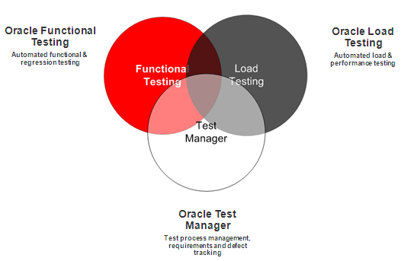

Oracle Application Testing Suite’s also has Accelerators for Oracle E-Business Suite to provide a comprehensive solution for ensuring the quality and performance of Oracle E-Business Suite applications. The Functional Testing Accelerator for Oracle E-Business Suite extends Oracle Functional Testing to enable automated functional and regression testing of Oracle E-Business Suite applications. The Load Testing Accelerator for Oracle E-Business Suite extends Oracle Load Testing to enable load and performance testing of Oracle E-Business Suite applications. The Testing Accelerators for Oracle E-Business Suite are components of Oracle Application Testing Suite, the centerpiece of the Oracle Enterprise Manager solution for comprehensive testing of packaged, Web and service oriented architecture–based applications. The tool has very intuitive interface and offers following benefits.

- Automates complex Oracle EBusiness Suite transactions for both functional testing and load testing
- Supports automation of both Web and Oracle Forms application interfaces and protocols
- Provides custom test cases to validate application content
- Enables parameterization of test scripts for data-driven testing
- Simulates loads of hundreds to tens of thousands of concurrent users while minimizing hardware requirements
- Gathers critical infrastructure performance metrics to identify bottlenecks under load
- Provides an intuitive Web based console to configure and run load tests and share real-time results with distributed users

High level tasks

- Define scope & strategy
- Define test scenarios
- Define steps in scenarios
- Create test scripts
- Determine test data needed
- Create and load test data
- Create test database
- Create test environment
- Execute test
- Produce report

Required resources:

- Project manager
- Performance test team lead
- Technical analyst
- Database administrator
- Application administrator
- System administrator
- Network administrator
- Business analyst
- User representative
- User emulation scripting resource
Strategy:
Performance management strategy identifies and prioritizes the business critical transactions, establishes the techniques and metrics that will be used to monitoring actual performance and defines the process to identify, track and resolve problems. Developing performance testing strategy requires discovery sessions and workshops with IT, business users, DBA team, architecture team, and stake holders. Given below are high level points addressed during developing the strategy for performance testing.
- Determine and document performance testing scope, objectives, milestones, and critical success factors.
- Identify project policies, risks, and assumptions related to the performance test
- Review Initial Architecture and Application Mapping
- Identify the set of critical business transactions and document their performance requirements.
- Identify and document any system wide or overall performance expectations or Service-Level Agreements.
- Study and evaluate impact of key dependencies of the performance test to other project efforts.
- Validate that the technical architecture will support anticipated processing requirements during a simulated peak concurrent workload for:
- Validate that the technical architecture will scale successfully to the anticipated growth rate
- Validate batch processing does not adversely impact OLTP performance and visa/versa
- Validate performance of key transactions from remote sites by executing those transactions by live users offset by automated virtual user to supplement the concurrent load.
- Validate that the processing required to perform a financial period close can be successfully completed with the time frame requirements on a consolidated Global Single Instance under peak workload conditions.
- Track and report cpu utilization and memory during test execution, including run queues, paging
- Track and report I/O service times, wait times
- Track and report transaction performance as measured by Oracle users
- Track and report SGA performance (waits, enqueues, latches, etc.) io performance, sql statement resource usage
- Track and report cpu utilization and memory for forms server processes during test execution
- Track and report cpu utilization and memory for web server processes during test execution
- Develop baseline performance metrics that can be used to tune the production system.
- Identify specific performance metrics and the methods to monitor, collect and report them.
- Establish specific quality controls relating to performance.
- Establish acceptance criteria and change management related to the performance test
- Establish processes and procedures to identify, track and resolve performance problems.
- increase user satisfaction and system acceptance by minimizing performance related issues.
- Reduce effort required for reactive performance remediation.
- Define a method to evaluate the performance impact of a change to software or hardware.
- Validating that the workload being tested accurately reflects the work to be executed against the production system
- Ensuring that a test environment exists which is similar in architecture as well as data volume and contents to the production system
- Creating a performance test team which has functional and business process expertise on it as well as technical expertise
- Access to performance testing expertise and tools
Process:
The performance testing subproject is aligned with OUM our implementation methodology into five phases as given below:
- Inception
- Elaboration
- Construction
- Transition
- Production

Each of these phases has well defined tasks that need to be accomplished using our templates to make sure nothing is missed. The tasks closely interact within each phase and their output is fed to other phases. Following tasks are completed during five phases of the project for a successful performance testing:

Phase | Task
Inception | Conduct Performance Management Workshop
Elaboration | Define Performance Management Requirement and Strategy  Define Performance Testing Strategy  Identify Performance testing Models and Scenarios  Design Performance Test Scripts and Programs  Design Performance Test Data and Load Programs
Construction | Build Performance Test Scripts and Programs  Construct Performance Test Environment and Database  Conduct Performance Test Dry runs
Transition | Execute Performance Test  Create Performance Test Report
Production | Conduct Production Performance Management
A flow diagram depicting the interaction during different phases of performance testing is given below:
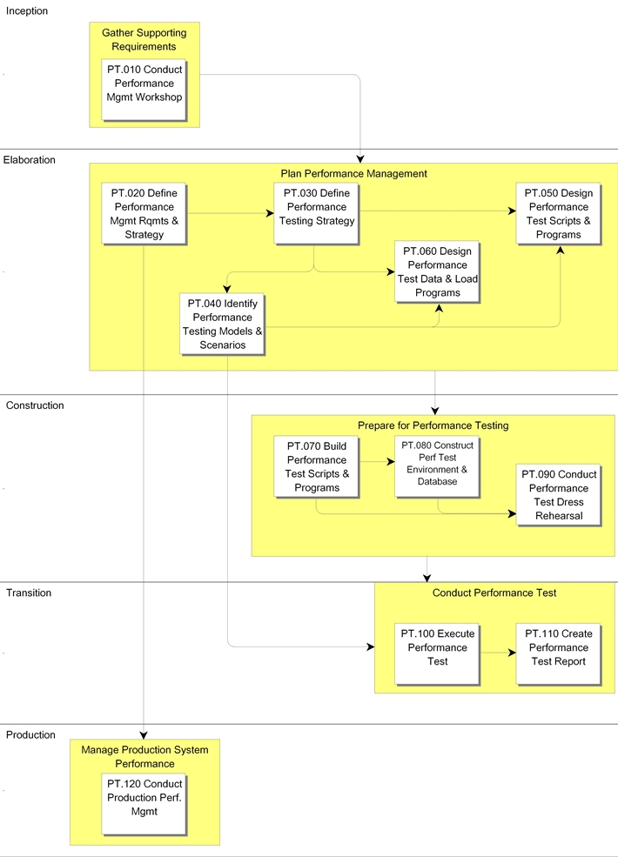
Performance team leader is responsible for leading the Performance Management process and reviewing the work products. The team leader plans, directs, and monitors the day-to-day work of the team. The team leader assigns work packages to the team members and makes sure they understand the requirements. The team leader is responsible for building team cohesion, motivating the teams, and providing assistance and encouragement to the team members. Each team leader performs the final quality control and quality assurance for the team by reviewing all work products. The team leader also signs off on team work completion and quality. Work that is not up to quality standards is returned. Team leaders review work products from other teams when these work products may impact aspects of the system. The team leader reports the team's progress to the project manager.
Conducting Performance Management Workshop task is the first step in the Performance Management process. The Performance Management Workshop familiarizes the client with the concepts of proactive Performance Management, the need to define performance requirements for business critical transactions, establishment of metrics and monitoring related to performance management, Service-Level Agreements (SLA) and the appropriate use of Performance Testing. The workshop also provides a mechanism to gather information on performance needs and expectations that should be used to develop the Performance Management Requirements and Strategy.
After the Performance Management Workshop, the Performance Management process continues with the definition of the Performance Management Requirements and Strategy. The performance management requirements and strategy documents the business critical transactions and their performance requirements, what metrics will be established and reported, what monitoring or instrumentation will be implemented and what control processes will be put in place. A performance testing strategy document is created which defines the scope and objectives of performance testing for the project and outlines the strategy that will be used to execute the performance test. The specific transaction scenarios and models are defined in the performance test transaction models and scenarios, design of test scripts and programs is documented in the performance test scripts and programs design, and any test data or load programs required are documented in the performance test data and load programs design document.
The Performance Management team defines the scope of testing and relates it to point-in-time snapshots of the transactions expected in the real production system. Technical analysts create or set up transaction programs to simulate system processing within the scope of the test and populate a volume test database against which to execute the transactions. Once the system and database administrators have created the test environment, the project team executes the test and the final results are documented.
Critical success factors:

- A limited and well defined test scope
- Clearly defined success criteria for the test
- Validating that the workload being tested accurately reflects the work to be executed against the production system
- Ensuring that a test environment exists which is similar in architecture as well as data volume and contents to the production system
- Creating a performance test team which has functional and business process expertise on it as well as technical expertise
- Access to performance testing expertise and tools

Summary

A well planned performance and load test helps enterprises reduce performance risk, establishes performance viability of a specific architecture, and offers details on additional system capacity for future work load.

