Folders Forms

and

Using Folders in Oracle Applications
Contents

Overview 3
Creating a New Folder (View) 5
Folder Assignments 7
Other capabilities 10
File Export Option 10
HR Folder Forms / Lists 12
Folders – Alternate Views 13
Master Items Form 13
Order Organizer 14

Overview
When you open a folder form, the Folder option on the application top menu is enabled. Use this to configure the layout and settings of the folder.
The Folder Tools option will give you a floating menu, from which you can execute some of the folder tasks.
A folder with no customisation, will open with default settings, showing pre selected columns and performing an unrestricted query.
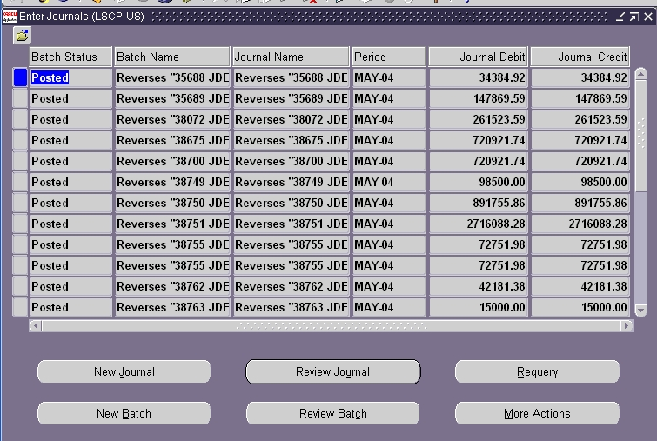

In most cases when you see this icon on the top of a multi-row form it means that there is a capability to create a custom folder.
A custom folder is a different view of the data as seen in the form above. This can be modified to include (or exclude) specific columns that are part of the dataset in this screen.
You cannot add any additional columns that are not already part of the dataset.
The capability to do this is controlled by a Profile Option that can allow or disallow folder creation and modification. This profile option is ‘Folders: Allow Customization’.
This can be set at the Site, Application, Responsibility or User levels.
Once the capability is available for the users/specific users to customize folders they choose the option on the Menu Bar on top of the form.

The option is called ‘Folder’

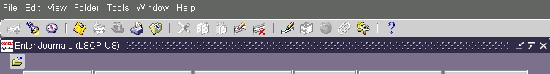

Or you can click on the option on the menu buttons here to get something that looks like this to manipulate and customize the folders. This is the Folder tool option.

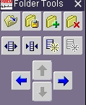

Floating Toolbar – invoked by choosing the Folder Tools option

Creating a New Folder (View)

This is the process you use to customize the folders and create a new one. Always create a new one as opposed to modifying the existing one that is what comes with Oracle.

Click the option to create a new Folder – by using the Folder Option on the menu and choosing New as shown below –

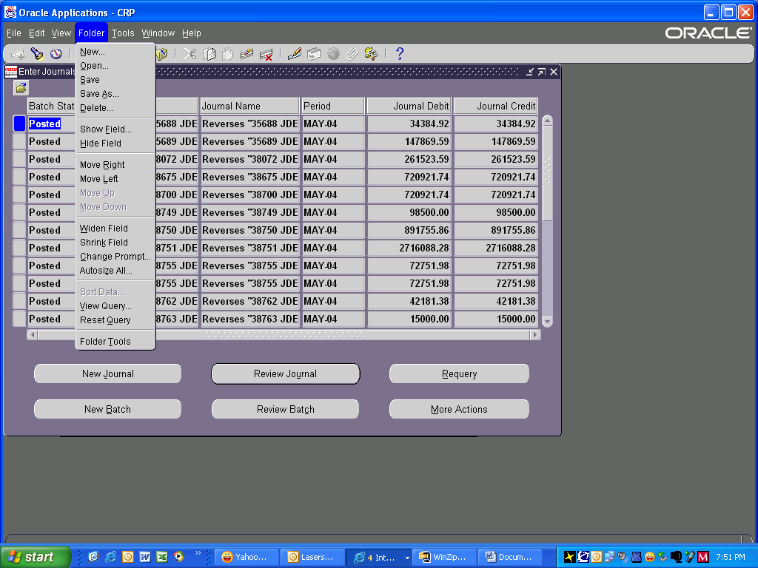

Once you click on the New Folder the following dialog box will pop up

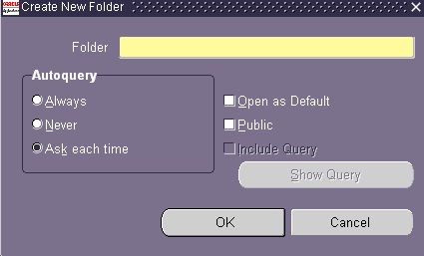

The options on the dialog box are as follows –

AutoQuery – It is always better to check either Never or Ask Each Time. Always will bring up data records that were part of the initial data set when you created the Folder.

With the same response also do not check the include query option.

Do not check Open as Default because this will override the choice of the default folder for every user.

Always check Public option if you want this folder available to all users to assign and choose from a drop-down list. You can keep this private for yourself by not checking the Public option.

If you choose the Open as Default option then this will become your default folder and you will loose the “Oracle” default.

In case you choose the option to ‘Include Query’ for the folder it will always come up with the set of data that was on the form when you created the Folder. This option should not be used if you do not intend to use the same set of data whenever you choose to use this Folder.

In case you use the Include Query Option then you must every time go and reset query form the Folder form before you can see any other data in that Folder.

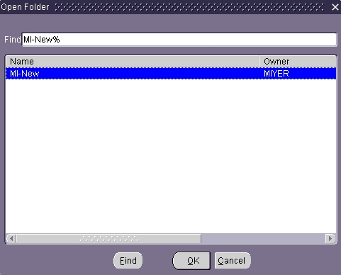

Folder Assignments

You can use the System Administrator Responsibilities by using the Administer Folders menu option.

You can use the form to query up an existing Folder that you have created.

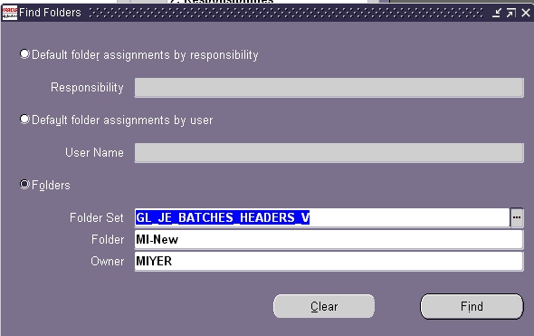

Once you click Find Button the system will find the relevant Folder and display as below

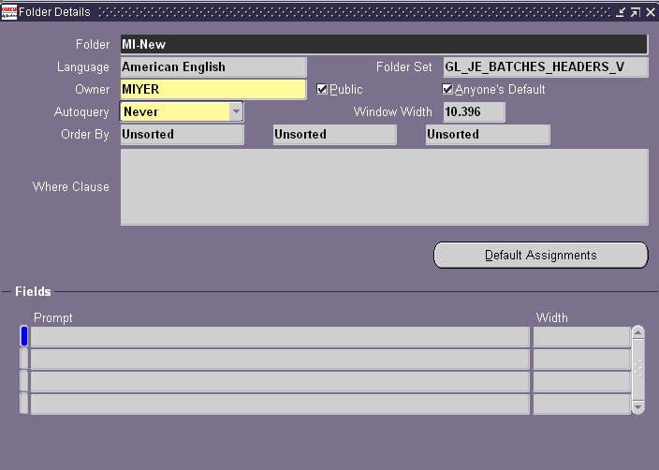
In this form you can only change the Owner and the option to perform AutoQuery when the folder is displayed for the user. The options here are Always, Ask and Never. These are the same options that you get as checkboxes when you create the Folder.

You can view ‘default’ assignments for this folder by clicking on the Default Assignments button.

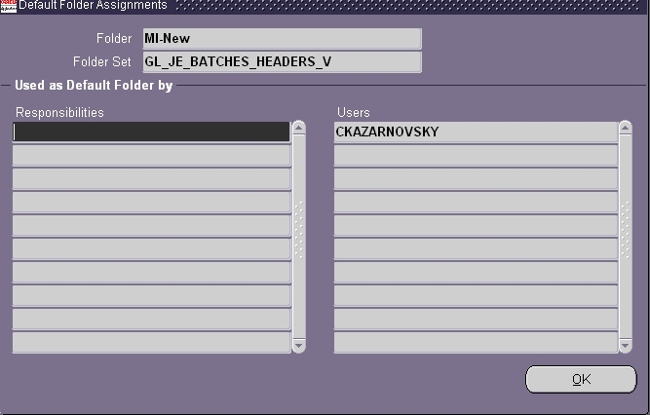

You can assign the Folders to Users or Responsibilities by the following method

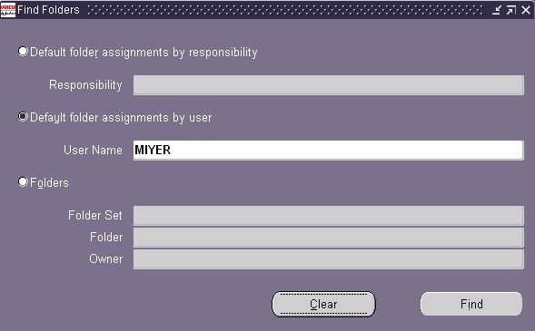

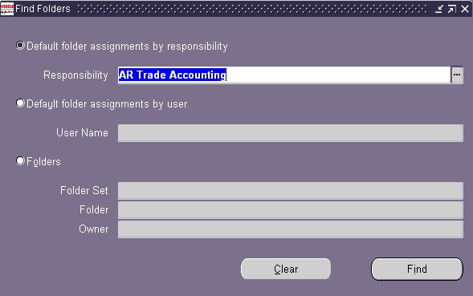

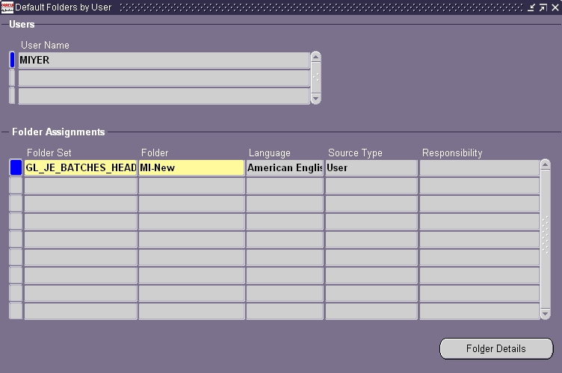

Other capabilities

Below are some other capabilities that are used normally with Folder Forms

File Export Option
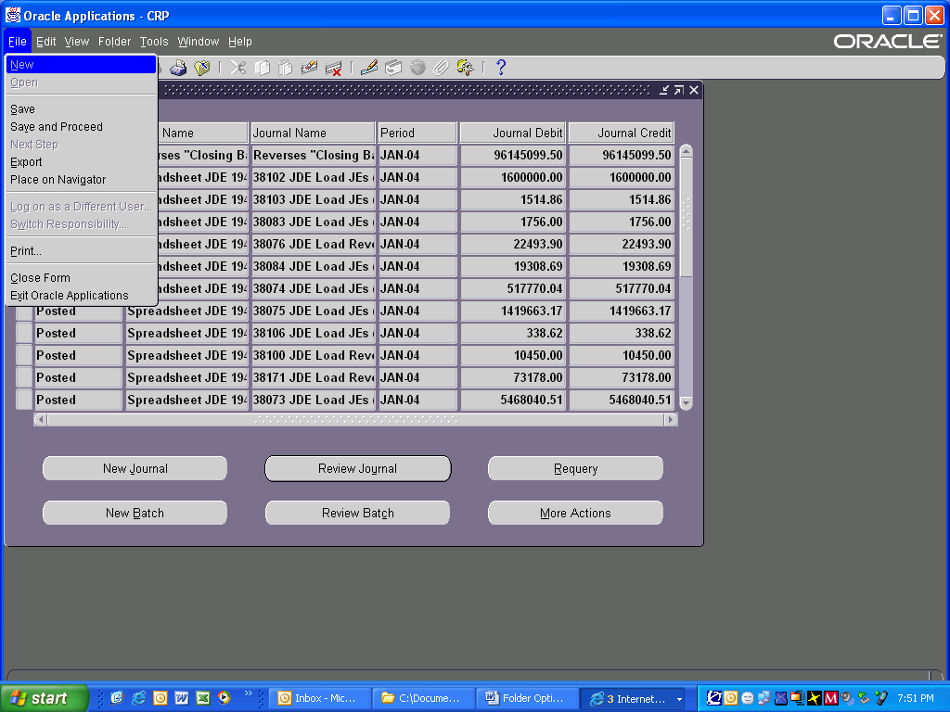

Oracle Applications allows you to export data that you see on the form (or a folder view) to a file – like excel – which can be then be used as a normal excel file. These are really useful when you want a quick dump of the data for reference or are trying to trouble-shoot some issue.

The File – Export option allows you to dump the data you see on the form (or data set you have queried). A great way to document current Profile Options for a given Responsibility or the defaults.

The default is a file type called “tsv”, that means tab separated values and can be opened by default in Notepad in most cases, but can also be configured to open in Excel, which is a choice for most users. 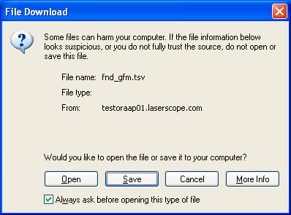
In HR however, this option does not exist because HR exports data in a different way, using the icon on the toolbar that has an Excel like icon and a left facing arrow on it.

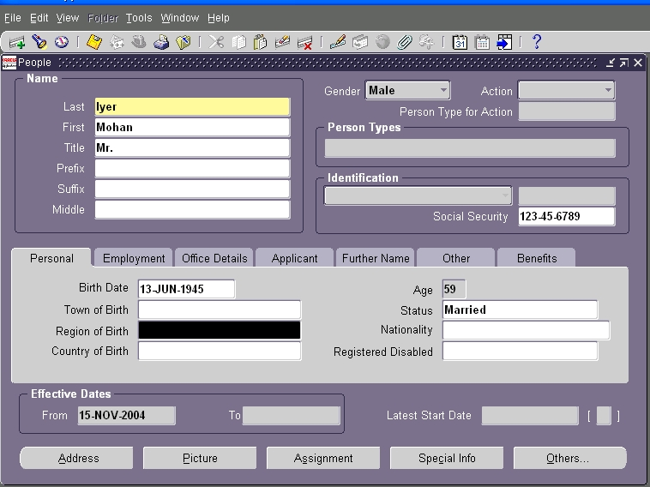
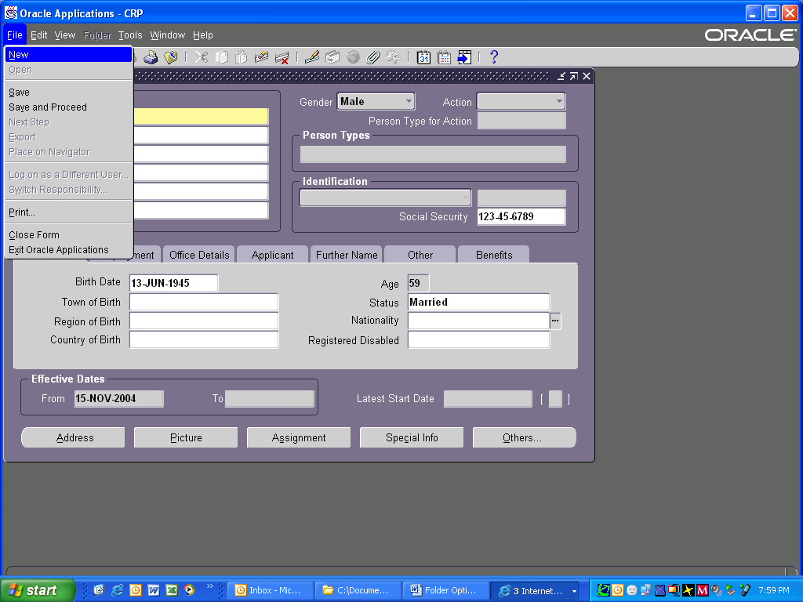

HR Folder Forms / Lists

The folder option in this form (HR People) is not enabled because HR forms do not allow Folder options in this manner to be customized. They however, have other options called View and Lists that contain each of these forms’ data in them and these can be then customized like other Folders.

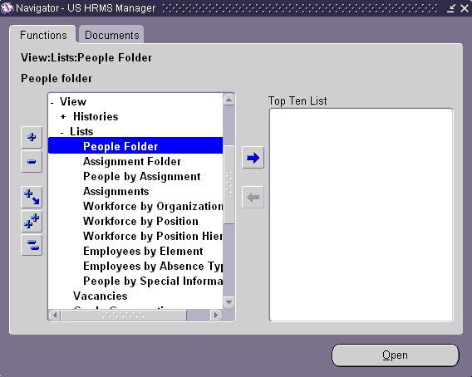

Folders – Alternate Views

Folder forms come in other flavors as well.

Master Items Form
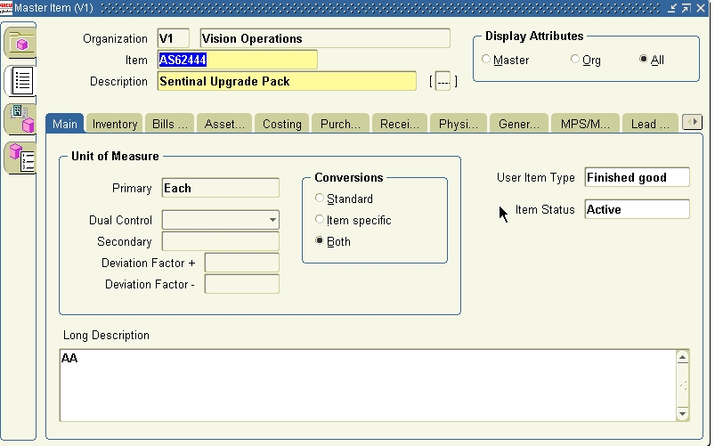
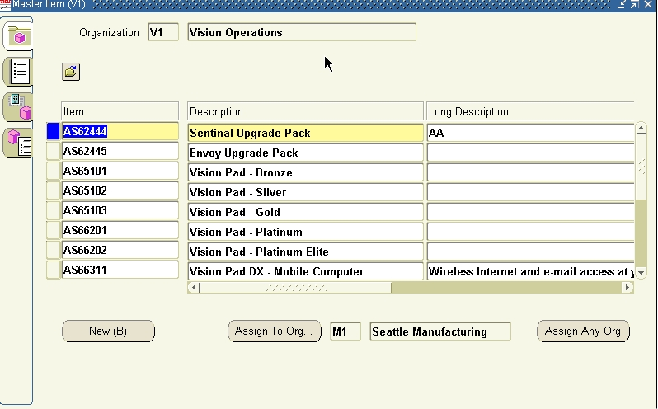

Order Organizer

Sales order Entry Form

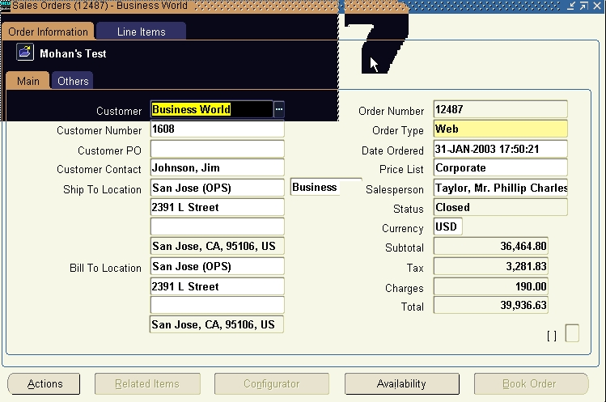
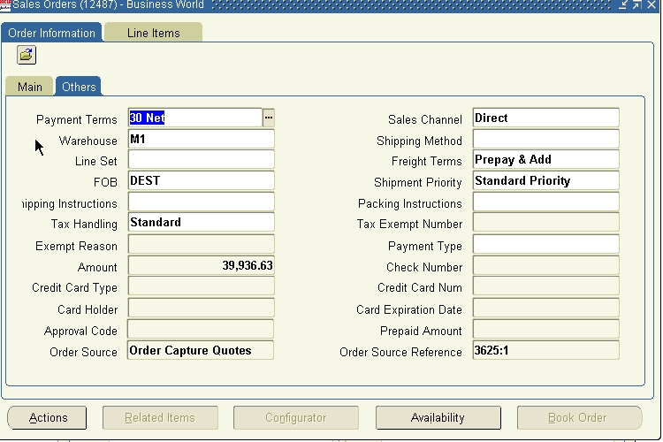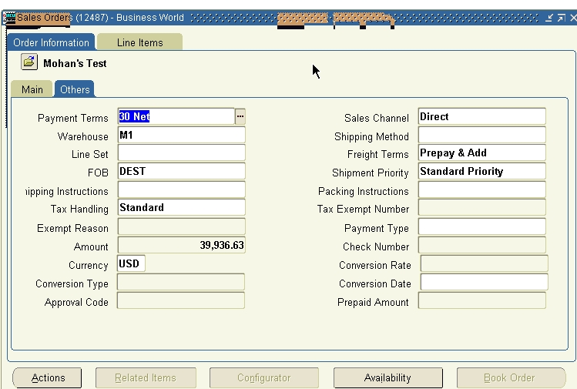

Folder Options from the Alt Menu on top of the form –

Option | Meaning | Comments
New | Open a new Folder from the existing one on the screen | Always create a new folder when re-arranging or making changes to a form view
Open | Open an existing saved folder
Save | Save a newly created or modified folder | Always save the folder after you make changes as a different name. DO not save the default folder after having made changes to it.
Save As | Save an existing folder with modifications with a different name | Use this option to make sure you do not change the default folder
Delete | Delete an existing folder
Show Field | Show an additional field in the folder view
Hide Field | Hide a field in the folder view
Move Right | Move the current field to the right
Move Left | Move the current field to the left
Move Up | Move the current field up
Move Down | Move the current field down
Widen Field | Widen the field that the current field
Shrink Field | Shrink the field that the current field
Change Prompt | Change the prompt that is displayed for the field on the screen (current field)
AutoSize All | Auto size all fields that are displayed on the form
Sort Data | Sort data in based on the first three fields shown on the folder view | This option will only sort data based on the first three fields on the form. The system will display a dialog box with the three field names and a column to choose a sort option – Ascending or Descending.
View Query | View the query that has been set for this folder when it was created. This option will also show the query if any additional one has been added during the current session
Reset Query | Reset a query that has been saved along with the folder creation
Folder Tools | Displays a floating icon that has few options form this menu

